FIRE SENSOR

This fire sensor circuit exploits the temperature sensing property of an ordinary signal diode IN 34 to detect heat from fire. At the moment it senses heat, a loud alarm simulating that of Fire brigade will be produced. The circuit is too sensitive and can detect a rise in temperature of 10 degree or more in its vicinity. Ordinary signal diodes like IN 34 and OA 71 exhibits this property and the internal resistance of these devices will decrease when temperature rises.

The fire sensor circuit is too sensitive and can detect a rise in temperature of 10 degree or more in its vicinity. Ordinary signal diodes like IN 34 and OA 71 exhibits this property and the internal resistance of these devices will decrease when temperature rises. In the reverse biased mode, this effect will be more significant. Typically the diode can generate around 600 milli volts at 5 degree centigrade. For each degree rise in temperature; the diode generates 2 mV output voltages. That is at 5 degree it is 10 mV and when the temperature rises to 50 degree, the diode will give 100 milli volts. This voltage is used to trigger the remaining circuit. Transistor T1 is a temperature controlled switch and its base voltage depends on the voltage from the diode and from VR and R1. Normally T1 conducts (due to the voltage set by VR) and LED glows. This indicates normal temperature.

When T1 conducts, base pf T2 will be grounded and it remains off to inhibit the Alarm generator. IC UM 3561 is used in the circuit to give a Fire force siren. This ROM IC has an internal oscillator and can generate different tones based on its pin connections. Here pin 6 is shorted with the Vcc pin 5 to get a fire force siren. When the temperature near the diode increases above 50 degree, it conducts and ground the base of T1. This makes T1 off and T2 on. Alarm generator then gets current from the emitter of T2 which is regulated by ZD to 3.1 volt and buffered by C1.Resistor R4 ( 220K) determines the frequency of oscillation and the value 220K is a must for correct tone. To set the fire sensor circuit, keep a lighted candle near the diode and wait for 1 minute. Slowly adjust VR till the alarm sounds. Remove the heat .After one minute, alarm will turns off. VR can be used for further adjustments for particular temperature levels.

Fire Sensor Circuit Diagram:

[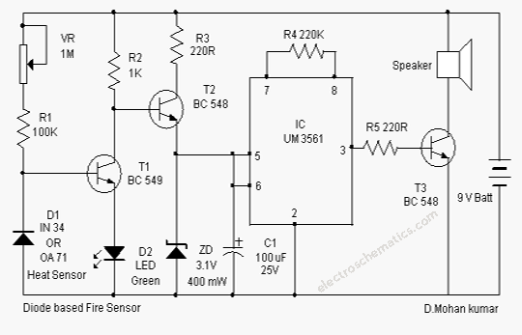](http://electroschematics.com/wp-content/uploads/2009/12/Diode-based-Fire-Sensor.png)